

**Proposal for Website Upgrade and Digital Marketing Setup**

By

Brian Munene – Wave kenya Regional Co-ordinator

Michael Murwayi – Software DevelopER

# Introduction

WAVE Children's Foundation has been a beacon of hope for underprivileged children, transforming countless lives through its impactful initiatives. As the organization continues to grow, expanding its reach and engaging a global audience is imperative to maximizing its impact. A state-of-the-art website, coupled with a strategic digital marketing approach, will enable WAVE to connect with more donors, volunteers, and supporters worldwide. This proposal provides a roadmap for upgrading the website and implementing a comprehensive digital marketing strategy to achieve these goals, ensuring that the foundation’s mission reaches a broader audience and fosters deeper connections.

With the constant change and advancement in the field of technology and online marketing, it is essential for modern organizations to adapt their operations to fully leverage their media assets, including websites and social media accounts. By staying ahead of these trends, WAVE can ensure maximum impact and sustainable growth.

# WEBSITE UPGRADE

An optimized, user-friendly website is the cornerstone of effective online engagement, serving as both a digital storefront and a communication hub. A well-designed website ensures that visitors can easily navigate through content, find critical information, and interact with the organization seamlessly. It sets the tone for credibility, professionalism, and trust, which are essential for fostering long-term relationships with donors, volunteers, and stakeholders. The proposed improvements aim to transform the website into a dynamic, engaging platform that not only meets current user expectations but also anticipates future needs.

1.1 **Modern and Responsive Design**

* Implement a clean, visually appealing design.
* Ensure the site is fully responsive for mobile, tablet, and desktop devices.

1.2 **Enhanced Navigation**

* Simplify the menu structure for easy access to key information such as programs, donation portals, and volunteer opportunities.
* Add a search function for quick content discovery.

1.3 **SEO Optimization**

* Implement technical SEO improvements, including metadata, alt tags for images, and URL structure.

1.4 **Integrated Donation System**

* Upgrade the donation portal with secure payment gateways.
* Provide options for one-time or recurring donations.

1.5 **Analytics Integration**

* Set up Google Analytics to track website traffic, user behavior, and conversion rates.

1.7 **Accessibility Compliance**

* Ensure the website adheres to WCAG (Web Content Accessibility Guidelines).

# DIGITAL MARKETING

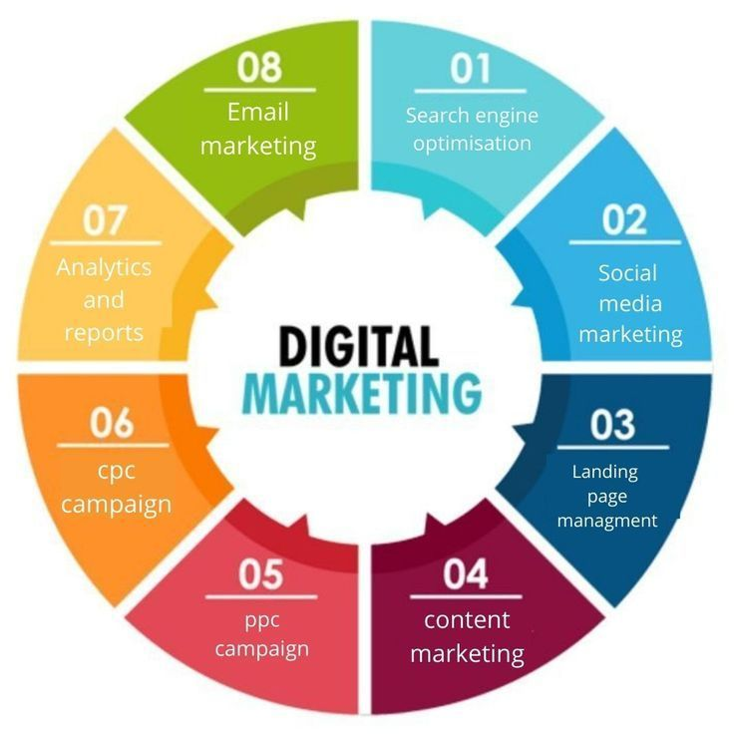To complement the upgraded website, implementing a robust digital marketing strategy is essential for driving traffic, enhancing visibility, and fostering deeper engagement with the target audience. Digital marketing serves as a powerful tool to bridge the gap between the organization and its supporters by leveraging diverse channels to communicate WAVE's mission effectively. Below, we outline the steps involved in this strategy and their significance for maximizing reach and impact:

2.1 **Search Engine Optimization (SEO)**

* Conduct keyword research to identify terms donors and supporters search for.
* Create high-quality content optimized for these keywords.
* Ensure the website’s structure supports effective indexing by search engines.

2.2 **Social Media Marketing (SMM)**

* Establish a presence on key platforms (Facebook, Instagram, Twitter, LinkedIn).
* Post regular updates, success stories, and events to foster engagement.
* Run targeted ad campaigns to reach specific demographics.

2.3 **Email Marketing**

* Build and segment an email list.
* Send personalized newsletters with updates, success stories, and donation opportunities.
* Use automation tools to enhance efficiency and reach.

2.4 **Content Marketing**

* Launch a blog section featuring stories of impact, volunteer experiences, and organizational updates.
* Create video content to share across YouTube and social media platforms.
* Use infographics and eBooks to deliver compelling messages.

2.5 **Pay-Per-Click (PPC) Advertising**

* Set up Google Ads campaigns to increase visibility.
* Use retargeting ads to re-engage website visitors.
* Optimize ad spending through detailed analytics and performance tracking.

2.6 **CPC Campaign Management**

* Strategically implement cost-per-click campaigns tailored to WAVE’s goals.
* Monitor and refine ad performance for maximum ROI.

2.7 **Analytics and Reports**

* Regularly analyse data from social media, SEO efforts, and ad campaigns.
* Generate comprehensive reports to measure effectiveness and refine strategies.
* Use insights to guide future campaigns and resource allocation.

## **BENEFITS OF IMPLEMENTATION**

3.1 **Increased Visibility**

* A modern website and SEO practices will ensure the foundation ranks higher on search engines, driving more organic traffic.

3.2 **Enhanced User Experience**

* A streamlined, responsive design will make it easier for users to engage with the foundation’s content and make donations.

3.3 **Improved Engagement**

* Digital marketing will create opportunities for meaningful interactions with supporters, fostering loyalty and long-term relationships.

3.4 **Higher Donations**

* With a secure and user-friendly donation system, supporters are more likely to contribute.

3.5 **Actionable Insights**

* Analytics integration will provide data to make informed decisions about campaigns and strategies.

## CONCLUSION

Investing in a website upgrade and implementing a comprehensive digital marketing strategy is not just a tactical move but a transformative step for WAVE Children's Foundation. This initiative will enable the foundation to significantly expand its reach, ensuring that its mission and programs are visible to a global audience. By enhancing its online presence, WAVE will effectively connect with more donors, attract new volunteers, and deepen relationships with current supporters. The strengthened digital infrastructure will not only amplify the foundation's message but also position it as a modern, forward-thinking organization capable of adapting to evolving digital trends and maximizing its societal impact.

We look forward to working with WAVE Children's Foundation to achieve these transformative goals.